**Project Report: Customer Relationship and Product Management (CRPM) System**

**1. Project Overview**

The goal of this project is to create a **database management system** that handles customer, product, and purchase data, and provides **analytical insights** into business performance using **Streamlit**. The system integrates a **MySQL database** to store and manage data, while **Streamlit** serves as an interactive dashboard to visualize important metrics such as **total revenue**, **top products**, **top customers**, and **product performance**.

Streamlit is used to build an interactive, user-friendly interface that presents key business insights in an easily digestible format, such as tables, metrics, and charts.

**2. System Architecture(file named backend.py)**

The system consists of several components that interact with the MySQL database to manage and analyze data. These components are as follows:

1. **DatabaseManager Class**:
   * Handles the connection to the MySQL database and provides functions to execute queries (e.g., for adding, updating, and retrieving data).
2. **CustomerManager Class**:
   * Manages customer data (adding, updating, retrieving, and deleting customers). Customers are flagged as active or inactive in the system.
3. **ProductManager Class**:
   * Manages product data (adding, updating, retrieving, and deleting products). Products are flagged as active or inactive, and their stock levels are managed.
4. **PurchaseManager Class**:
   * Handles purchase transactions, records customer purchases, validates product availability, and updates the stock levels after each purchase.
5. **Analytics Functions**:
   * These functions handle the aggregation and retrieval of sales, product, and customer data. They generate performance reports such as total revenue, top products, top customers, and product trends (best and worst-sellers).
6. **Streamlit Interface**:
   * The Streamlit app named **app2.py** serves as the front-end interface where users can interact with the system. It displays the results of the analytics functions, presents KPIs (key performance indicators) as metrics, and visualizes data through tables and charts.

**3. Core Functionality**

**3.1. Database Interaction**

The **DatabaseManager** class facilitates the connection to the MySQL database and provides functions to execute SQL queries. The key methods of this class include execute_query for modifying data and fetch_all for retrieving query results.

**3.2. Data Management**

The **CustomerManager**, **ProductManager**, and **PurchaseManager** classes abstract the CRUD (Create, Read, Update, Delete) operations for customers, products, and purchases:

* **CustomerManager**: Allows adding, updating, retrieving, and deleting customer records.
* **ProductManager**: Allows adding, updating, retrieving, and deleting products.
* **PurchaseManager**: Manages customer purchase transactions, ensuring product availability, recording purchases, and updating product stock levels.

**3.3. Analytics and Reporting**

The analytics functions aggregate the data to provide business insights:

* **Sales Report**: Provides an overview of total revenue, total sales, products sold, and remaining stock for active products.
* **Top Products**: Ranks the top-selling products based on the quantity sold.
* **Least Products**: Identifies products with the least sales.
* **Top Customers**: Ranks customers based on the total amount spent and the number of purchases made.
* **Product Performance**: Provides a comparison of the best-selling and least-selling products.

These functions aggregate data using SQL queries and return the results in a format suitable for visualization.

**3.4. Streamlit Interface**

The Streamlit part of the application is responsible for presenting the data to the user. The key elements of the Streamlit dashboard are as follows:

1. **Sales Report**: Displays the total revenue, total sales, total products sold, and stock remaining.
2. **Top Products**: Ranks and displays the top-selling products.
3. **Least Products**: Ranks and displays the least-selling products.
4. **Top Customers**: Ranks and displays the top customers based on their total spending and the number of purchases.
5. **Product Performance**: Displays trends for the best-selling and least-selling products in a visual format.

**4. Streamlit Dashboard Implementation**

The Streamlit dashboard provides an interactive experience for users to monitor and visualize business performance. The dashboard includes various sections such as:

* **Sales Report**: Displays key performance indicators such as total revenue, total sales, total products sold, and remaining stock levels.
* **Top Products**: Ranks and displays the top-selling products based on total sales, with details on their stock levels.
* **Least Products**: Ranks and displays products with the least number of sales, allowing users to identify underperforming products.
* **Top Customers**: Ranks customers based on total spending and the number of purchases, providing insights into the most valuable customers.
* **Product Performance**: Compares best-selling and least-selling products, providing a snapshot of product trends.

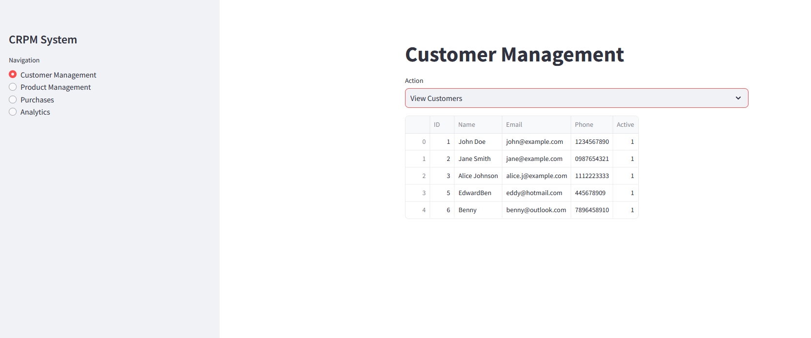

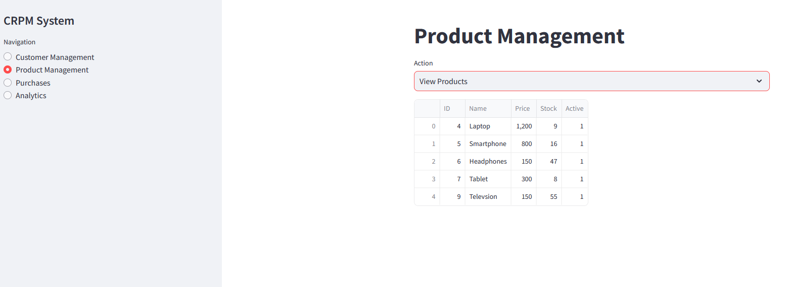

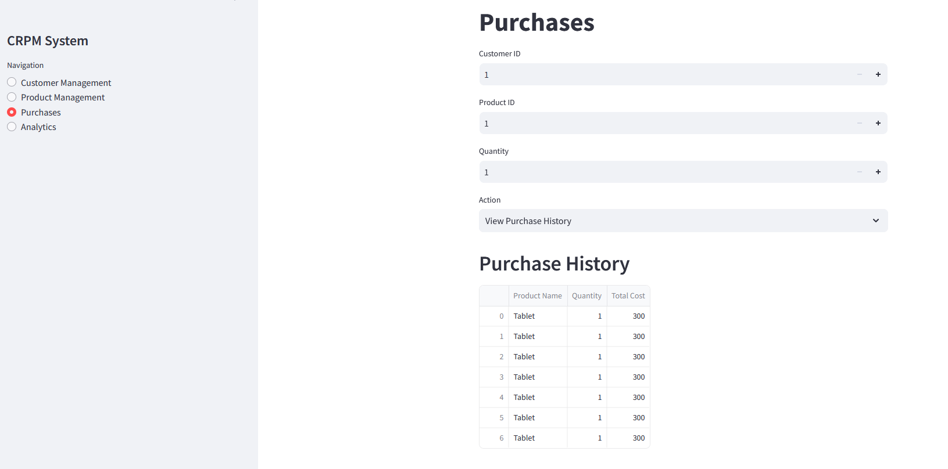

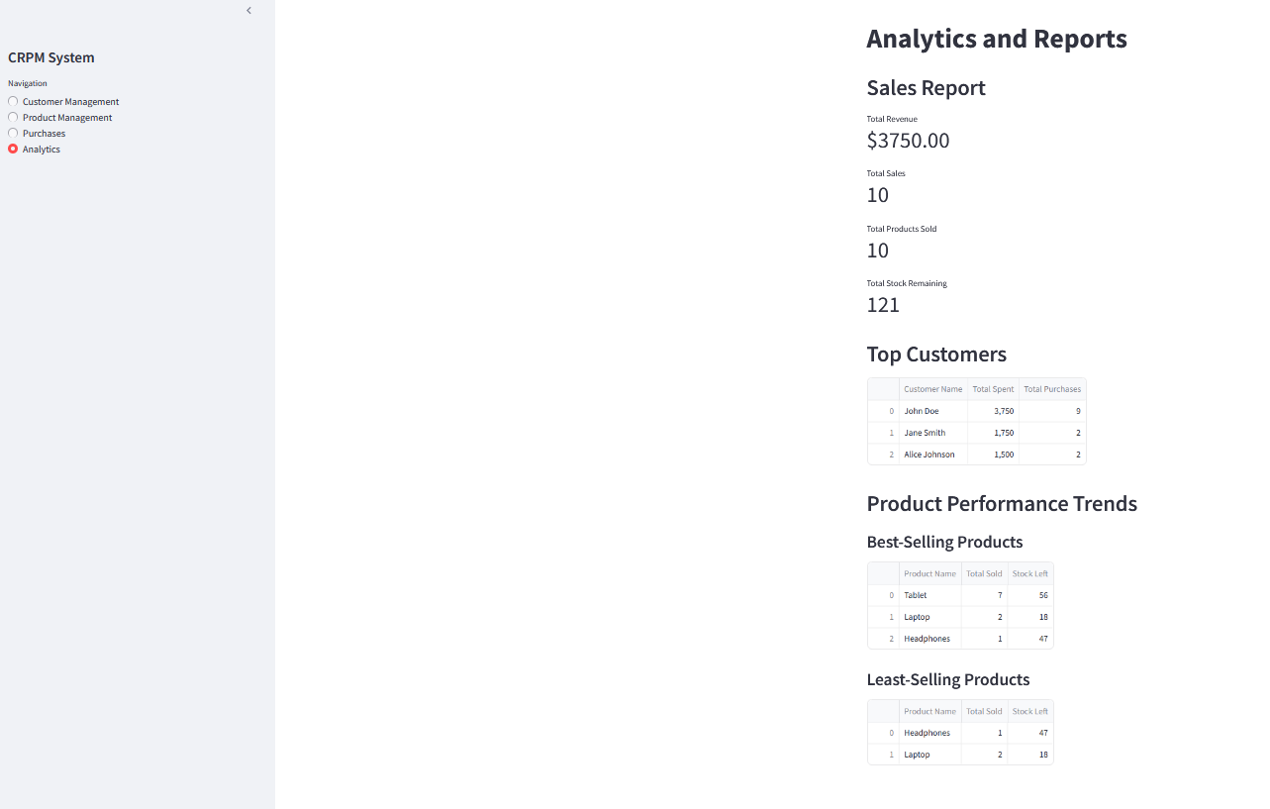

These sections allow users to interact with the data and make business decisions based on real-time insights. Additionally, the dashboard allows for dynamic querying and real-time updates, ensuring that the data presented is always up to date.

**5. Conclusion**

This project integrates a database management system with an interactive analytics dashboard to monitor key business metrics. The **MySQL database** stores and manages customer, product, and purchase data, while **Streamlit** provides a user-friendly interface to visualize and analyze the data.

With features such as **real-time sales reports**, **top products**, **customer insights**, and **product performance analysis**, the system enables businesses to make informed decisions and gain valuable insights into their operations. The integration of MySQL with Streamlit allows for scalable and interactive reporting, while the database management ensures data integrity and accessibility.